CYME Demo Instruction

Download and install the software

Click the link to download: CYME DEMO SOFTWARE
Installation password is: rsddr5791

Activate Method 1

1、Make sure that you have access to internet on your laptop / PC
2、Start the license manager 2 (Windows Start\ All Programs\CYME License Manager …)
3、Go to the Registration /Admin tab Enter the registration number: Provide by CYME representive
4、Wait until your license is active.
5、Enjoy the CYME software.

Activate Method 2

STEP 1 : Collecting the C2V file:
1. Start the license manager 2 (Windows Start\ All Programs\CYME License Manager …)
a. If you don’t have the license manager installed, you can download it from here:
http://www.cymetd.com/fullversion/LicenseManager20rev02.exe
2. Go to the Registration /Admin tab
3. Click the Collect C2V, and select Software Key
4. Save the File on your computer, and name it properly so that we can identify your key.
<Company name>_<key HASP ID#>.c2v
5. Send the C2V file to your CYME representative.

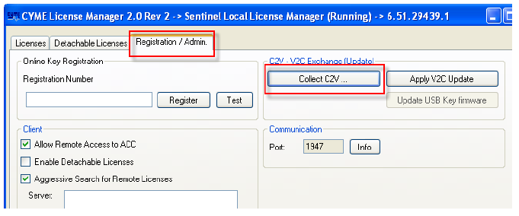

STEP 2 : Applying the V2C Update
6. You will receive the V2C file from the CYME Representative
7. Save the V2C on your computer. The location is not important.
8. Start the license manager 2 (Windows Start\ All Programs\CYME License Manager …)
9. Go to the Registration /Admin tab
10. Click the Apply V2C Update,
11. Load the V2C file you have saved and wait until you get “update successful” message.
12. You should be able to start the CYME program.

Here is the Tutorial video for CYME
http://www.cyme.com/tutorialvideos/

